**Viktor Logodazhki**

**INF 2040 – Website Development**

**Course Project**

For extra **functionality** I have used the **particle.js library**, which adds particles to my background. Every file is locally saved and edited to suit the feel and look of my website. In addition to that, I have added animations and hover effects for every part of the website. Lastly, in the footer I have provided links to my social accounts as to illustrate a more “professional” look for a website or to imitate the “contact us” scenario.

**Home page:**

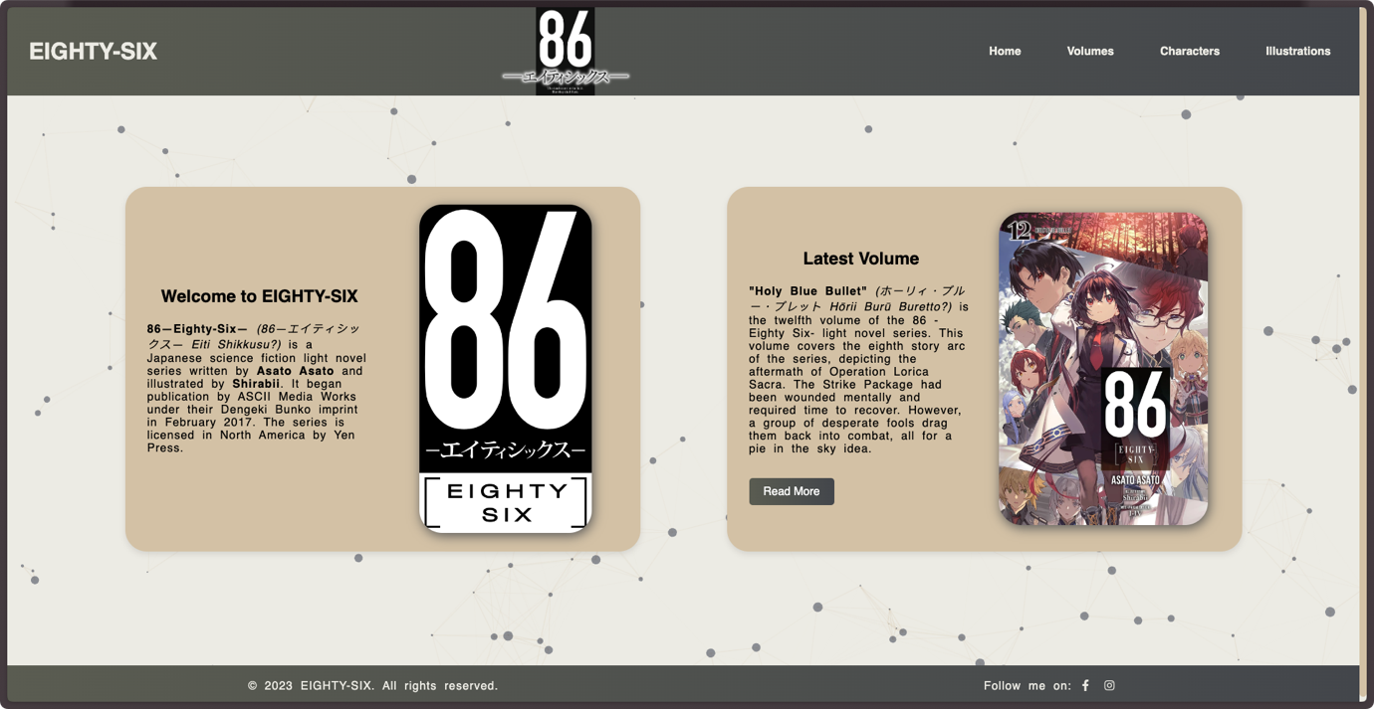

This is the home page of the website which illustrates the latest volume information and a brief introduction to the whole idea of the site and the Eighty-Six series as a whole.

**Volumes page:** 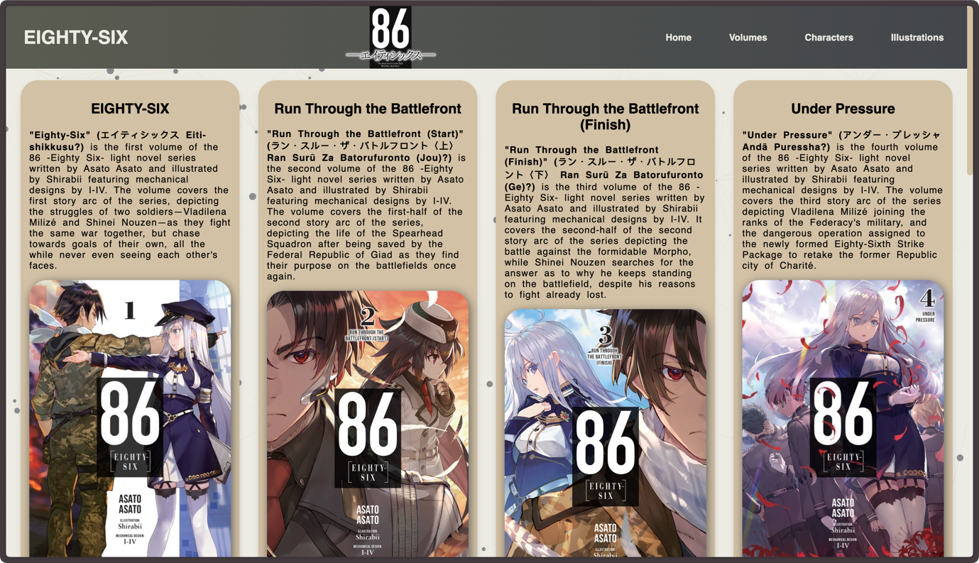

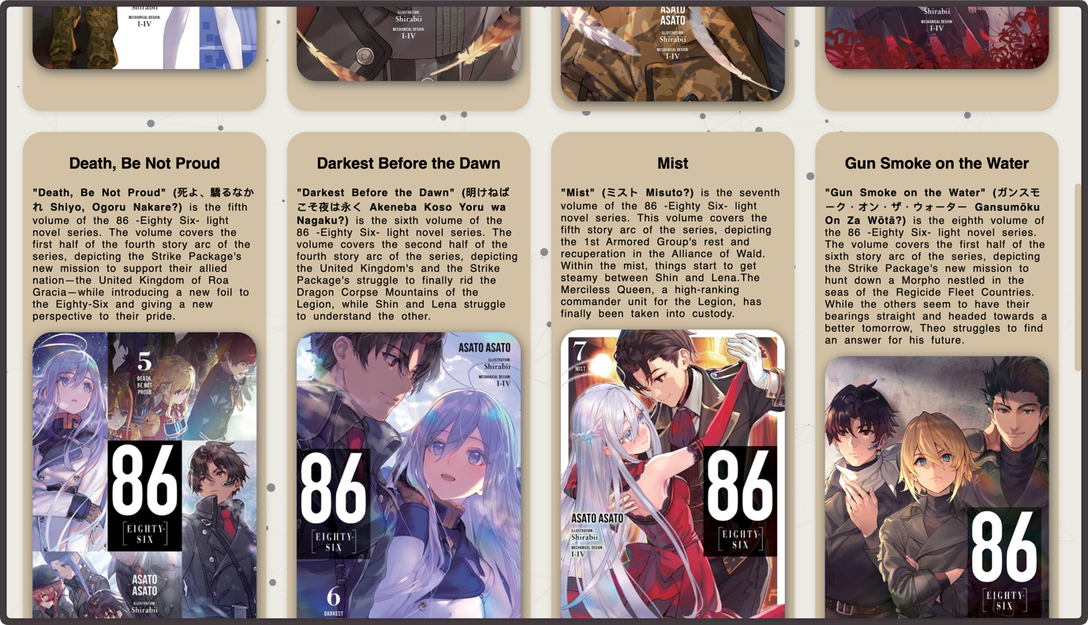

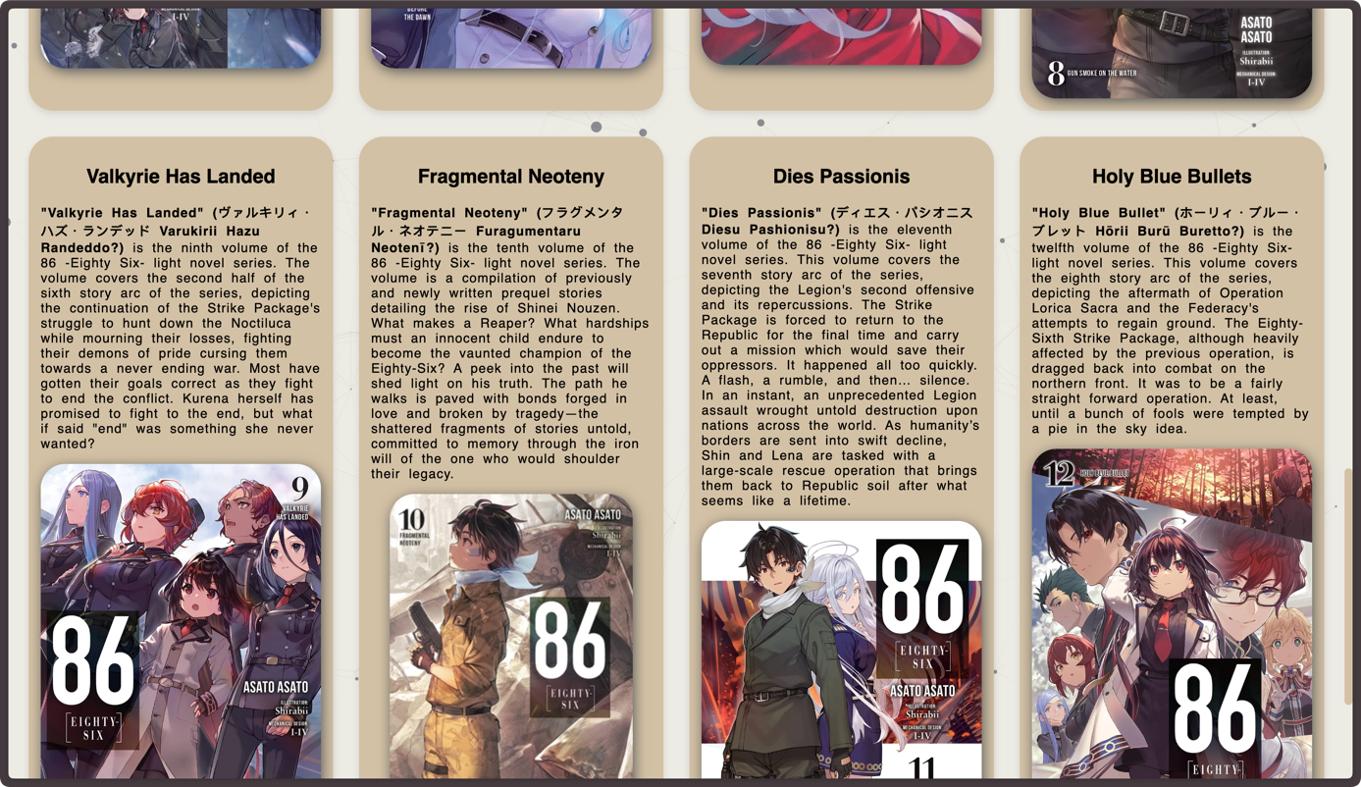

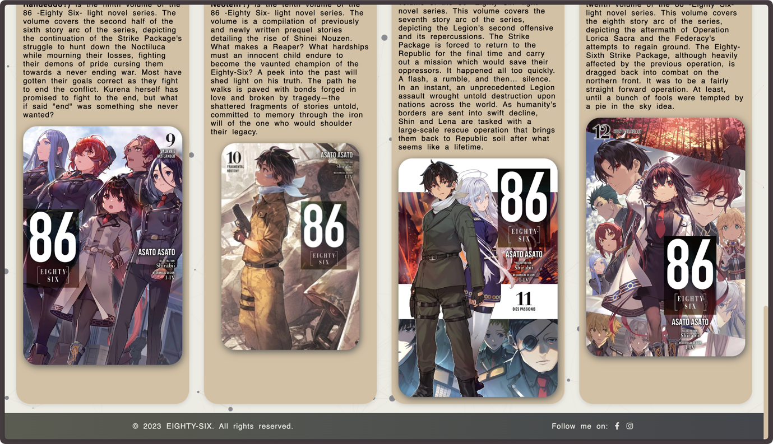

The role of this page is to illustrate each of the current volumes in the series and to provide a simple introduction to them or simply to give information about the content of each volume.

**Characters page:**

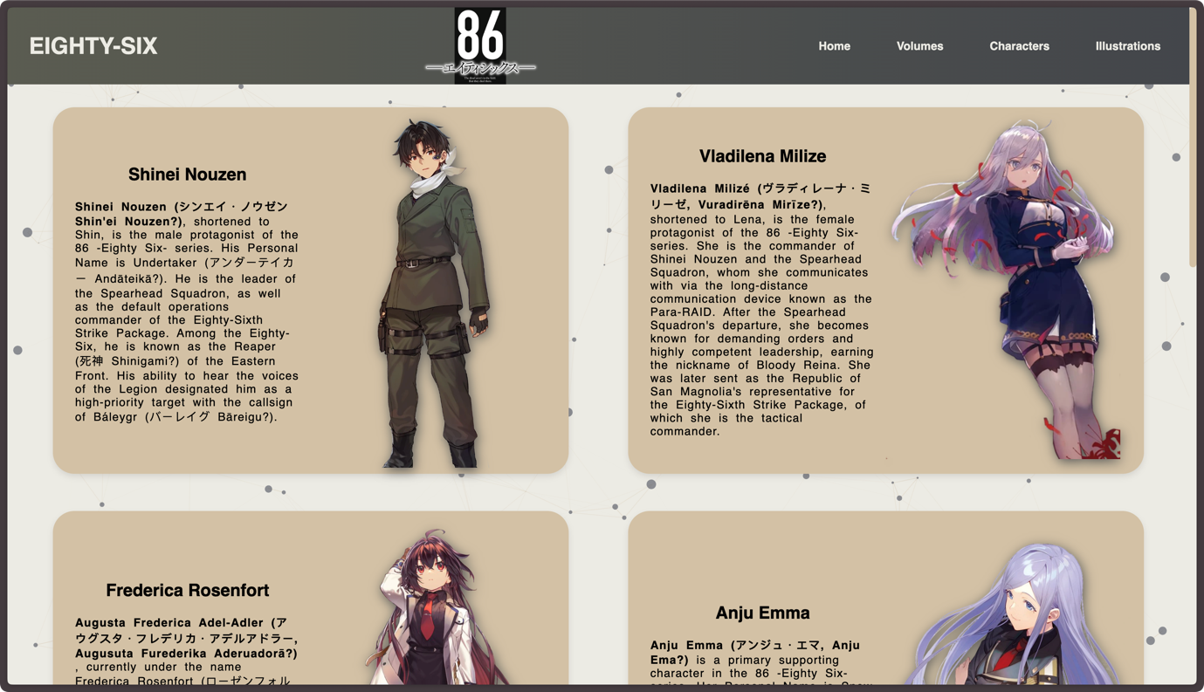

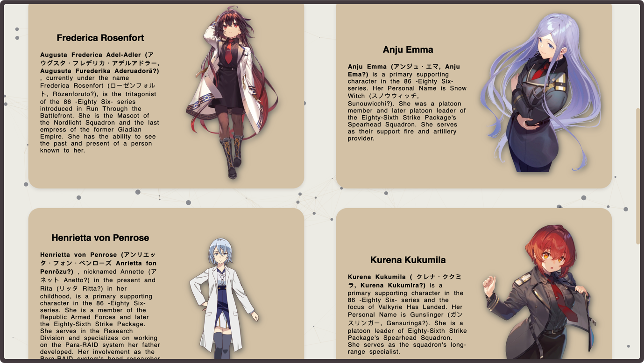

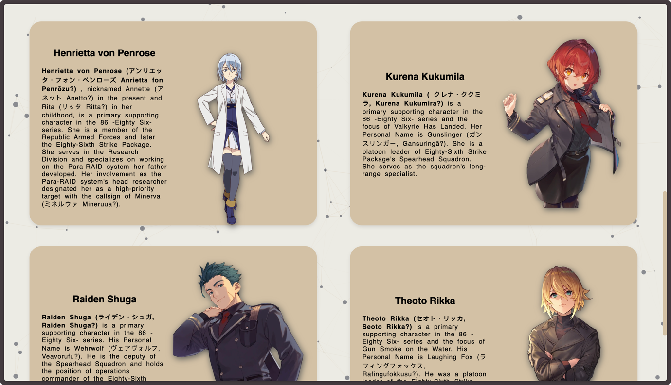

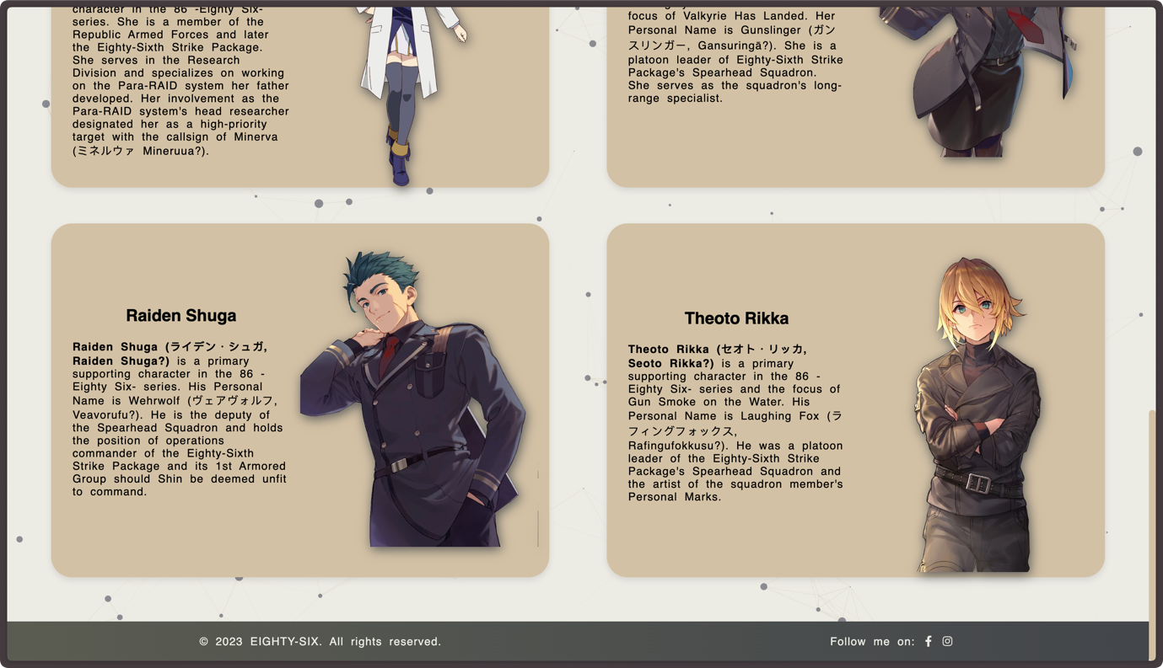

This page’s role is to illustrate the main characters of the series and to provide brief information about their role and what their current status is.

**Illustrations page:** 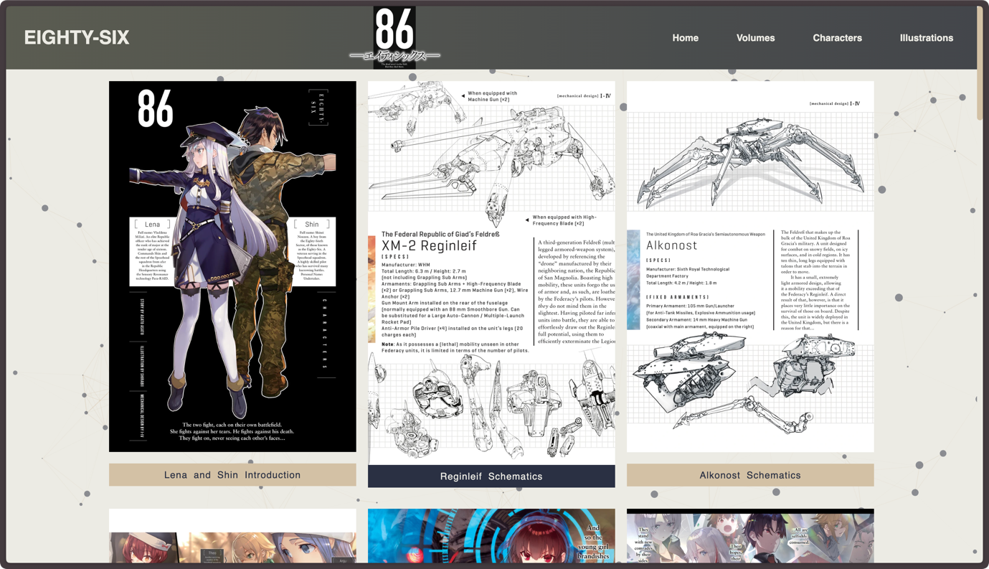

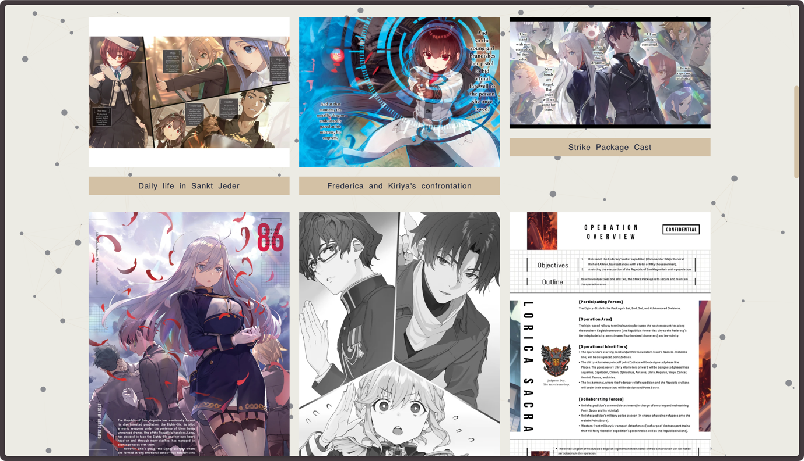

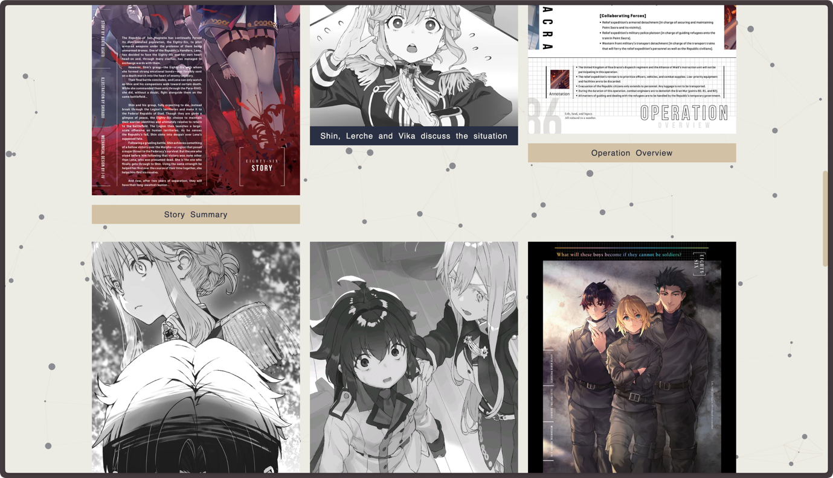





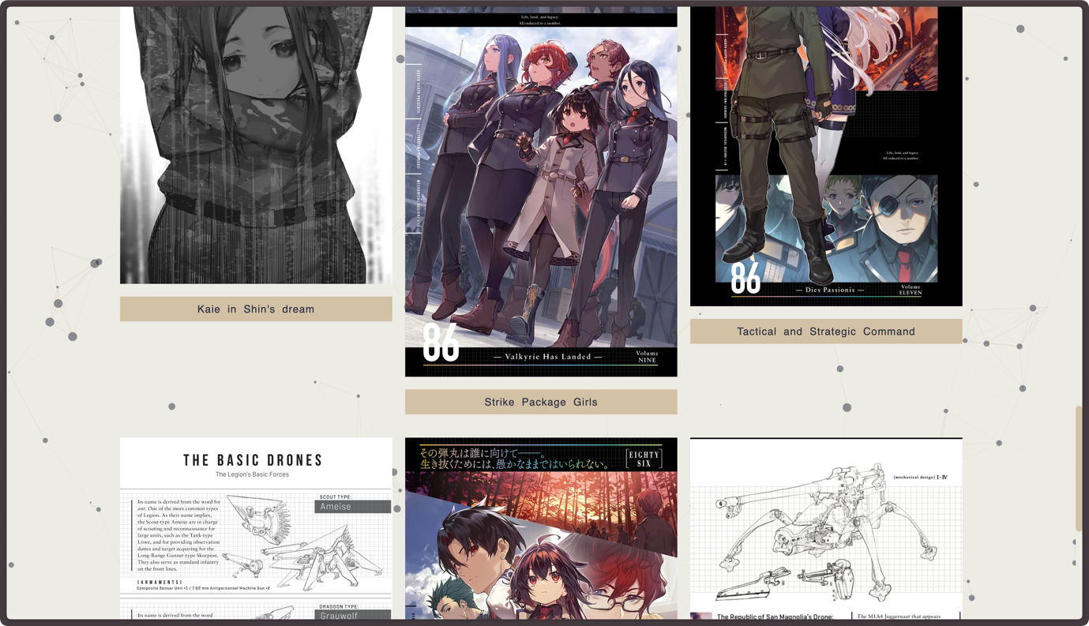

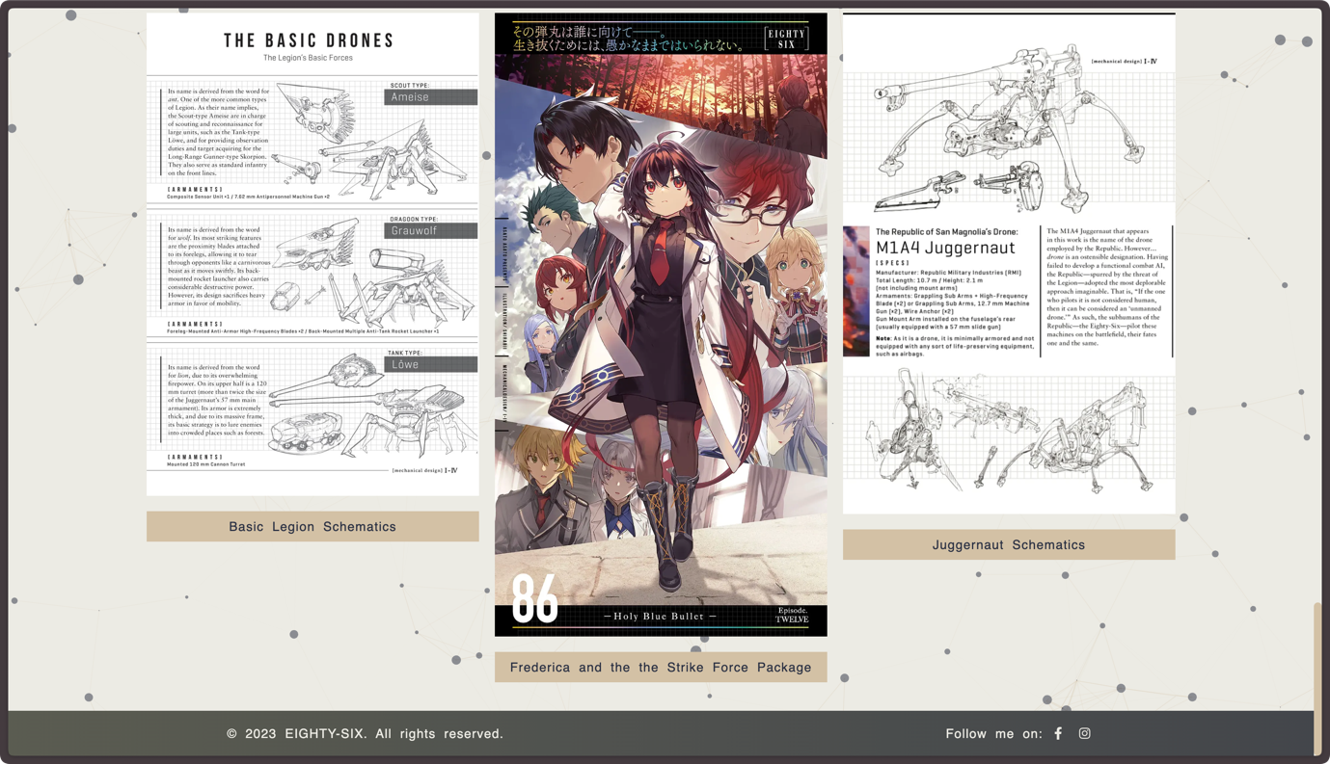

The role of the illustrations page is to showcase the different illustrations the light novel has. From character photos to mechanical ones – colored or not.

This is the whole website with screenshots covering each part of it. The only parts not covered are the regular and background animations, with the addition of the hover effects.